**Pizza Sales SQL Queries**

**A. KPI’s (Key Performance Indicator)  
  
Total Revenue**

SELECT SUM(total_price) AS Total_Revenue FROM pizza_table LIMIT 5;

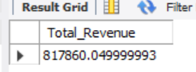

**Average Order Value**SELECT SUM(total_price)/COUNT(DISTINCT(order_id)) as Avg_Order_Value FROM pizza_table;

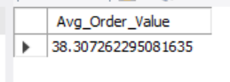  
  
**Total Pizza Sold**SELECT SUM(quantity) AS Total_Pizza_Sold FROM pizza_table;   
  
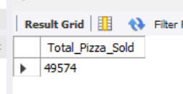  
  
**Total Orders**SELECT COUNT(DISTINCT(order_id)) as Total_Orders from pizza_table;

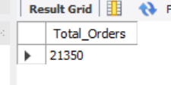  
  
**Average Pizza Per Order**SELECT SUM(quantity)/COUNT(DISTINCT(order_id)) AS Avg_Pizza_Per_Order FROM

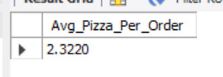

**B. Hourly Trend for Total Pizza Sold**

SELECT EXTRACT(hour from order_time) as Order_hour ,  
SUM(quantity) as Total_Pizza_Sold FROM pizza_table  
GROUP BY Order_hour ORDER BY Order_hour ASC;

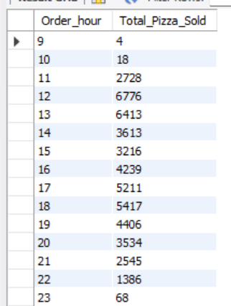  
  
**C. Weekly Trend for Total Pizza Sold**SELECT WEEK(STR_TO_DATE(order_date, '%d-%m-%Y'), 3) AS WeekNumber,  
YEAR(STR_TO_DATE(order_date, '%d-%m-%Y')) AS Year,  
COUNT(DISTINCT order_id) AS Total_orders  
FROM pizza_table  
GROUP BY WeekNumber, Year  
ORDER BY WeekNumber ASC, Year DESC  
  
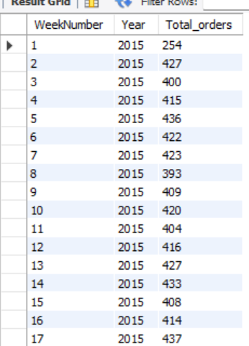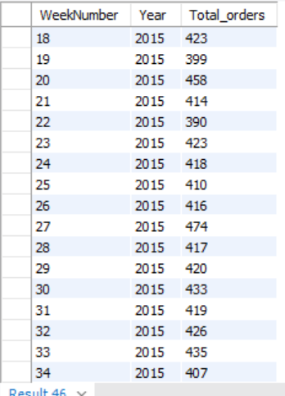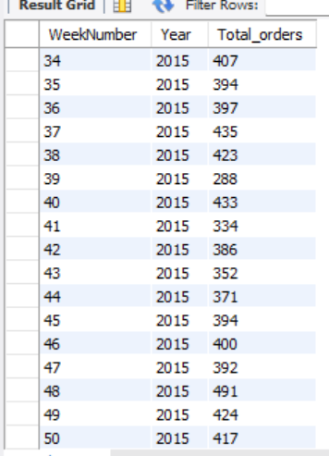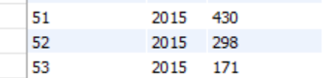  
  
**D. % of Sales by Pizza Category**SELECT pizza_category ,  
ROUND(SUM(total_price),2) AS total_revenue ,  
ROUND(SUM(total_price)/(SELECT SUM(total_price) FROM pizza_table)*100,2) AS PCT  
FROM pizza_table GROUP BY pizza_category;

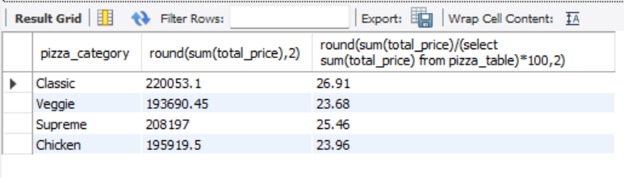  
  
**F. Total Pizzas Sold by Pizza Category**SELECT pizza_category, count(order_id) as Total_Pizza  
FROM pizza_table GROUP BY pizza_category;

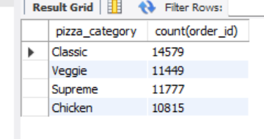  
  
**G. Top 5 Pizzas by Revenue**SELECT pizza_name ,  
sum(total_price) AS Revenue from pizza_table  
GROUP BY pizza_name  
ORDER BY SUM(total_price) DESC LIMIT 5;

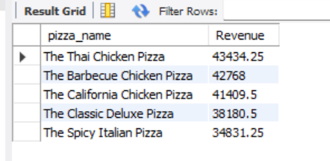  
  
  
 **H. Bottom 5 Pizzas by Revenue** SELECT pizza_name ,  
 sum(total_price) AS Revenue from pizza_table  
 GROUP BY pizza_name  
 ORDER BY SUM(total_price) ASC LIMIT 5;

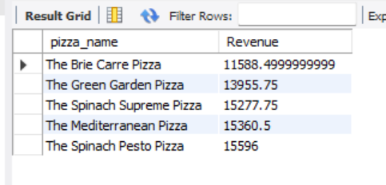

**I. Top 5 Pizza by Quantity**

SELECT pizza_name ,   
SUM(quantity) AS Total_Pizza_Sold FROM pizza_table   
GROUP BY pizza_name

ORDER BY Total_Pizza_Sold DESC LIMIT 5;

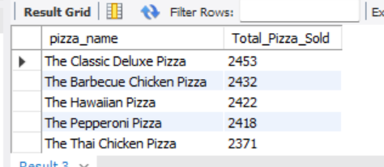  
  
**J. Bottom 5 Pizza by Quantity**  
SELECT pizza_name ,   
SUM(quantity) AS Total_Pizza_Sold FROM pizza_table  
GROUP BY pizza_name   
ORDER BY Total_Pizza_Sold ASC LIMIT 5;

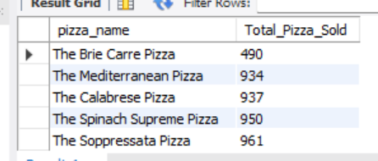  
  
**K. Top 5 Pizza by Total Orders**SELECT pizza_name ,   
COUNT(DISTINCT(order_id)) AS Total_Orders FROM pizza_table   
GROUP BY pizza_name

ORDER BY Total_Orders DESC LIMIT 5;

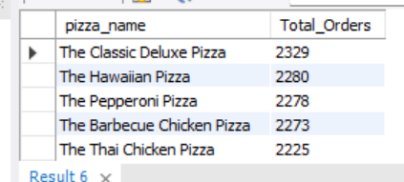

**L. Top 5 Pizza by Total Orders**SELECT pizza_name ,   
COUNT(DISTINCT(order_id)) AS Total_Orders FROM pizza_table   
GROUP BY pizza_name   
ORDER BY Total_Orders DESC LIMIT 5;

